**My Energy Efficient House**

Task: Design your energy efficient house.

Use the information placements provided to draw and label the key energy saving features on your house which help to reduce heat loss in winter and minimise heat gain in summer.

* Add a heading and arrow pointing to each energy saving feature of the house. If your energy saving feature is not already drawn, you need to add it to your house e.g awnings, pergola.
* Below the heading state why your key energy saving feature is important.
* 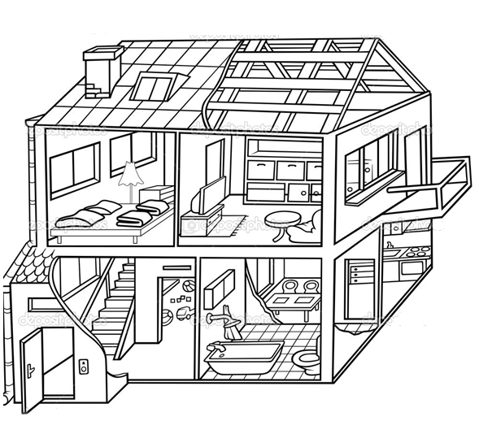An example has been done for you.

**Programmable Thermostats**

Programmable thermostats make it easy for homeowners to save energy and money. The thermostat can be programmed to reflect when people are home, asleep or on holiday.